Resources for Survivors of Dating and Domestic Violence

Welcome. We are here to support you.
We have created this guide to share information and resources for survivors of dating and domestic violence. If you have a hard copy or print any of the information, it is best to keep this is a place where your abuser cannot find it. This packet is intended to connect you with resources on-and off-campus and to provide you with support and options. We know this time in your life can be very stressful and that much of the language here may be triggering or upsetting. However, we also hope that you find this guide to be helpful and empowering.
The person or department who gave you this resource is available to help you. They can connect you to additional advocacy and assistance in reporting the violence if you choose to do so.
If you need to speak to someone right away, please call The Line at 773-494-3810 or the National Domestic Violence Hotline at 1-800-799-7233.

Table of Contents

- Loyola Advocacy Services…………………………………………………………………..Page 3

- Rebuilding and Grounding Techniques…………………………………………......Page 4

- Staying Safe While With Your Partner.……………………………………………….Page 7

- Safety Planning……………………..…………………………………………………………Page 11

- Sexual Assault Survivors Emergency Treatment Act, Crime Victim’s Compensation Act, Victims Economic Security and Safety Act ..………Page 15

- Orders of Protection………………………………………………………………………..Page 17

- Wellness Center Services…………………………………………………………………Page 19

- Loyola’ Policies Regarding Sexual Misconduct………………………………….Page 19

- Off-Campus Resources…………………………………………………………………….Page 20

Loyola Advocacy Services
The Wellness Center offers support and advocacy to students who have experienced gender-based violence, including sexual assault, sexual harassment, stalking, and intimate partner violence or domestic violence. Trained advocates are available to answer any questions that you may have. Confidential, non-judgmental services include:
- Information about what resources exist on- and off-campus for counseling, support, and legal advocacy
- Education about medical options and procedures, including evidence collection
- Assistance in reporting to Campus Safety, if you choose
- Information about reporting and support in navigating Loyola's resolution process, if you choose
- Assistance in creating a safety plan
- Referrals to counseling and other supportive campus and community services
- Assistance for significant others, family, and friends of survivors
You have options, and you are not alone.
The primary way to connect with an advocate is to call The Line at Loyola at 773-494-3810. The Line is open Monday-Friday, 8:30am-5pm and 24 hours on the weekend when classes are in session.
Visit https://luc.edu/coalition for more information. If The Line is closed and you would like to speak to someone right away, please call the Illinois Domestic Violence Hotline at 877-863-6338.
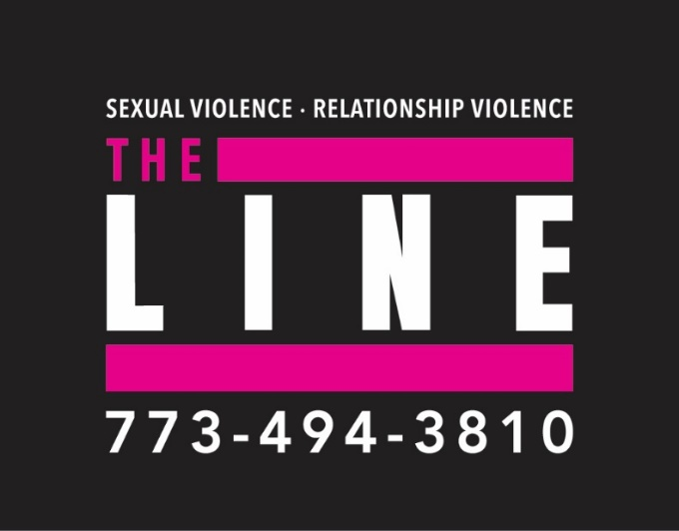

Rebuilding and Grounding Techniques

Tips on Rebuilding and Maintaining Support After the Isolation of Abuse
Isolation is a painful product of abuse and unhealthy relationships. Partners who behave abusively often intentionally separate their significant other from the people that care about them, because it offers them greater power and control over the relationship and survivor. Your partner might have asked or demanded that you not be around or communicate with people they suspect you are attracted to, or even long-term family or friends. They could have ordered you to stop going to the places or doing the things you once enjoyed. These expectations have no place in a healthy relationship – and you have the right to be part of a robust support network and community, as the social human that you are!
Whether you have left an abusive or unhealthy relationship, or remain in one, you could be feeling lonely and frustrated over the lack of social support available to you. We know that having a support network of friends, family, neighbors, and community members is important for healing and recovery. They can offer emotional support, hold on to important documents or evidence, or provide feedback for next steps. They can also aid and encourage your self-care, whether that be going with you on a walk, meeting for brunch, or just being a reassuring presence in trying times.
Here are some tips for rebuilding and maintaining social support after the isolation of abuse and unhealthy partners:

- Reconnect with yourself and your past
Write down how this relationship has affected you. If you keep a journal or post on social media, review entries from before this relationship. Reflect on the people you would spend time with, the activities you enjoyed, and the places you would go. Utilize this as direction for future steps and people in your past that you can contact.
- Reach out and rebuild relationships
It can be scary to make connections again, especially if there was “bad blood” that developed because of the pressure put on you by your abuser. Research shows though that expressing vulnerability, the feeling of being emotionally exposed, can bring you closer to others, and strengthen connections. Reflect on what happened between you and those friends or family, and write a message, email or letter to them speaking honestly about what happened and your desire to reconnect. Remember that there is always the possibility of rejection from those who don’t understand abuse, why it is so hard to leave, or why you had to do what you did while you were with your abuser. However, you might be surprised by the affirmative and supportive responses you get from those that love you.
- Throw a party or get together
Most people love the opportunity to connect and meet in groups. Invite people you have known in the past or people you would like to know better over to your home for a potluck, or if you are staying elsewhere, a public place like a park for a picnic.
- Join a local organization, club, or place of worship
There are also likely opportunities in your area or here on campus where you can connect with others, whether that be a knitting circle at a local coffee shop, on-campus club or place of worship. There you can meet new people that might be able to offer support in the future. Try reviewing websites like Meetup or checking out posters on campus to find likeminded individuals with similar interests as you.
- Go outside and be a part of the community
Make a goal for yourself to be an active member of the community and enjoy the comforts of Chicago and the surrounding area. Getting into the public sphere opens opportunities for building friendships and relationships. Check out the local bowling alley, hang out at the beach, or enroll in a class at a community center. You can also give back by volunteering at an animal shelter or to read to at your local library’s story-time.
- Consider a support group
Support groups can assist in connecting you with other survivors. They can be a safe space for you to talk about what you have experienced, and for you to brainstorm strategies that have kept you emotionally and physically safe. Support groups are located at domestic violence and social service organizations. You can locate support groups near you by reaching out to The Line, checking out the off-campus resources in this packet, or by reviewing online directories such as Psychology Today. Support groups are often available in person and online.
- Be gentle with yourself and celebrate your progress
Habits, unfortunately, do not disappear overnight. You might not immediately find all the emotional support you need or feel anxious about the steps required. Every step towards limiting your isolation is a success. Remind yourself of your accomplishments, no matter how small, and be sure to practice lots of self-care as you are trying these tips. You deserve it!
- Stay safe
As you are constructing your plan to decrease isolation, remember that you understand best what is needed to stay safe from your abusive partner. If any of these suggestions put you at risk for harm, consider a safer alternative. And if you need any assistance or have questions about how to decrease isolation, know that the National Domestic Violence Hotline is always available to brainstorm options and support you 24/7/365. Chat at www.thehotline.org or call 1-800-799-SAFE (7233).
Adapted from April 12, 2019 / in Get Help Today, Offering Support, The Hotline by Eric, a Hotline Advocate
Grounding Techniques
Grounding techniques are especially useful during times of stress, emotional disturbance, and exposure to troubling, disturbing and/or triggering stimuli. These techniques help you reconnect to the present and feel calmer and safer in the here and now. They are based upon evidence-based practices and are used as forms of self-care for a wide range of individuals working to maintain their wellness during overwhelming and difficult experiences.

Techniques you can use in classes or meetings
- Say a safety statement to yourself: “My name is __________; I am safe right now. I am in the present, not the past. I am located in ____________; the date is _____________. What I am feeling right now is valid, but I don’t need it; I can put it away. I am safe right now.” You can also write this to ground yourself. This can be helpful if you are being actively triggered, experiencing disorientation related to trauma, or experiencing another acute stress response.
- Repeat a favorite saying: Have a mantra, quote, or prayer on repeat in your mind that helps calm and soothe you. Positive self-talk can also be helpful. Use these words and their personal meaning to you as a way to ground and soothe yourself.
- Physically ground your body: Dig your heels into the floor, focus on the tension needed in your muscles to do this. Become aware of the pressure on your body of the seat supporting you. Notice how deep breaths into your belly push the small of your back into the chair behind you. Scan through your body and notice what it is in contact with. Continue to focus on deep, long, slow, and “low” breaths that extend into your belly. Let your shoulders and chest remain still as you breathe and try to keep them from rising and falling. Bring your awareness into your body and away from the tension of pain and anxiety.
Additional Grounding Techniques
- Carry a polished stone or soft piece of cloth with you to touch. Hold something that you find comforting and notice how it feels in your hands.
- Eat or drink a favorite food. Enjoy it slowly. Don’t do anything else while you are consuming it except focus on enjoying and savoring it.
- Concentrate on your breathing. Take a deep cleansing breath in through your noise and count. Exhale slowly through your mouth for twice as long. Continue for five minutes.
- Find your pulse on your wrist or neck and count the beats per minute.
- Write in your journal or color in a coloring book. Pay attention to yourself holding the pencil.
Adapted from Amherst College Grounding and Self Soothing Techniques and James Madison University’s Grounding Techniques

Staying Safe While With Your Partner
Adapted from Everyday Feminism, written by Maisha Z. Johnson
If you’re being abused by your partner, and you’re reading this right now, then you have awe-inspiring strength. You have the courage to seek out ideas on how to take care of yourself. When I was being abused, the only advice I found was about how to leave an abusive partner, or how to heal after you’ve left. But for a long time, I wasn’t ready to leave. And you and I aren’t the only ones to stay with a partner who’s been abusive.
The very nature of intimate partner violence (IPV) is that it often escalates gradually over time. Then, before you know it, you’re in a relationship marked by abuse, with no end in sight. On average, survivors attempt to leave seven times before leaving for good. Let’s just acknowledge that leaving any relationship is hard. Abuse isn’t going to make it any easier, and in fact, there are even more obstacles to leaving an abusive partner. So it’s entirely understandable if you’re not ready to do that.
You have your own reasons for staying in your relationship right now. Maybe you’re financially dependent on your partner or you’re afraid they’ll out your immigration status, HIV status, sexual orientation, or gender identity. Maybe you love your partner. Maybe you’re afraid of what they’ll do if you leave. Whatever your reason, only you know what’s best for you. Staying with your partner doesn’t make you hopeless. It does mean that you need and deserve to have ways to keep yourself safe. So let’s talk about how:
Get informed about what’s happening- Only you know your situation best, so nobody else can tell you what to do in your relationship. But intimate partner violence is complicated, which is why there’s no easy answer to the question of why you’re still with your partner (and you don’t owe an explanation to anyone). If you’re being abused, educating yourself about IPV can help you identify cycles of abuse, signs of danger, and all of the reasons why it’s not your fault. That means you’ll be able to sort out some of the confusion and self-doubt that can come up when you’re in a relationship with an abusive partner.
For example, some of the most confusing moments in my relationship came when I did exactly what my ex-partner told me to do, only to have him later claim that he’d told me to do it differently. I felt like a failure as he accused me of being incapable of listening or doing anything right. Those moments put me on edge, worried that every move I made was the wrong one. So I can’t even tell you how reassured I felt when I learned that there’s a term for his behavior: gaslighting.
Gaslighting leads survivors to doubt our own perceptions. Once I realized where this doubt was coming from, I regained some of my ability to trust my own sense of what was happening. That trust relieved some of the anxieties and self-loathing that had me feeling miserable, guilty, and disappointed in myself. And gaslighting was just one of many behaviors I recognized among the characteristics of intimate partner violence. Included in the signs of abuse were the dysfunctional aspects of our relationship that I thought were my fault or hurtful only because of my oversensitivity. I was floored when I found that I wasn’t the only one experiencing the things I was so embarrassed to admit were happening to me.
Maybe you’ll come across something surprising when you learn about dating violence. Maybe you’ll feel a little less alone, or a little more sure of yourself. And hopefully, the information you find will also help you avoid minimizing the abuse – trying to convince yourself or others that it’s not a big deal. Instead, you can trust your feelings when you know something’s not right and decide what, if anything, you’d like to do about it.
Hold On To Your Sense of Self (And Don’t Let Go)- I felt like I’d lost my sense of self to the abusive partner I was with. Many other survivors have told me they can relate. You might put your partner’s needs before your own. You might feel like the relationship is all-consuming, that you have no life or identity apart from it. Implicit in the very definition of intimate partner violence – a pattern of power and control – is your partner’s control over parts of your life. But you haven’t lost all your power. You can still make choices (good choices!) as you’ve already demonstrated by doing what you’ve done so far to survive. And you still get to be your own person – and take care of that precious person.
I know that can be hard to do. When I was hearing constant insults from my partner, I believed the toxic messages telling me I was worthless. But I wasn’t worthless, and neither are you. So think about how you can combat the toxicity, and hold on to your sense of self.
You could come up with messages of self-love, your own compassionate mantras to replace messages that tear you down. If your partner or your negative self-talk tells you that you’re worthless, tell yourself something like, “I’m valuable and loveable.” If your partner blames you or you blame yourself for the abuse, replace that message with “It’s never my fault, and I’m doing the best I can to survive.” Find joy whenever you can: Is there a song that rejuvenates you? An online community you can join? A memento that reminds you of someone who cares about you? Reach out for connection with someone who’s not your partner. Isolation is a common characteristic of abuse, and it’s one of the reasons many survivors feel dependent on their partners. Maintaining some connection with even just one person – a trusted friend, neighbor, or coworker, for instance – can keep you grounded in the world outside of your relationship. The key to maintaining your sense of self is doing something that’s just for you and honoring the strength it takes for you to do that, no matter how small. You think so much about what your partner wants from you, and you deserve to spend as much time as you can thinking about you.
Make a Plan- You may feel stuck, like you know you’re being mistreated, but you don’t know what to do about it. This hopeless feeling is really discouraging, but you do have options. A safety plan can help you figure out and prepare for those options.
Most safety plans focus on preparing to leave your partner or protecting your physical safety. This information is useful to have, in case you change your mind about staying in the relationship, or in case of a violent incident. So you can check out the safety plan aspect of this packet if you’d like. But you also deserve emotional well-being right now, even while you’re not planning to leave your partner. So our safety plan’s going to be a little different. This is all about preparing to protect your well-being and alleviate some of your stress in non-emergency situations.
What works for some survivors won’t work for everyone, so this guide is meant to be a starting point to help you figure out what’s best for you. I suggest writing down your plan – that way, you’ll have all of your options in one place for reference (be sure to keep it someplace safe from your abuser).
- Identify your needs- When you’re used to putting your partner before yourself, it can be pretty hard to figure out what it is that you need. So ask yourself:
  - In what ways does my partner hurt me? Make a list, and don’t limit it to physical injuries. How do they hurt you with their words or actions?
  - What will help me heal from that pain? Don’t wait to get medical attention for physical pain. For each of the ways your partner hurts you emotionally, consider what would support your healing.
  - What will I get out of taking care of this need? You may be used to dismissing your needs, but this plan is all about taking care of them. For each harmful action, consider why it’s important for you to heal from it.
  - For example, if your partner is constantly putting you down, you’ll need something to lift you up, which will help you feel good about yourself instead of believing you’re inadequate.
- Build Options to Meet Your Needs- For each action that calls for healing, you may have several options to choose from. Here are some tips:
  - Start with what you already know, listing all the ideas that come to you when you think of dealing with each abusive action.
  - Reflect on what how you’ve dealt with this struggle in the past, to include the strategies that have already worked for you.
  - Talk with a counselor, a hotline, or a trusted friend to help you brainstorm ideas for the areas where you feel stuck.
- Write Out Your List of Ways to Take Care of Yourself for Each Abusive Action
  - Keeping a computer file or notebook with positive affirmations that make you feel good about yourself. Repeating one of those affirmations to yourself each time your partner puts you down.
  - Thinking of a friend you can always count on to help you feel good about yourself, and calling or texting them to say that you could use a pick-me-up.
  - Preparing a thought to counter each of the put-downs your partner uses. For example, if someone insults my intelligence, it may help to say, “I’m smart as hell, and I’ve got the coping skills to prove it.”
  - Ignoring the put-downs (and finding something positive to focus on instead).

- Keep Your Options Within Reach
  - Now that you know your options, you can do any necessary preparations to make sure they’re available. Decide where you’ll keep this plan, so you can look at it and remember your options when you feel stuck. Our lives and relationships change over time, so revisit this plan often to adjust for changes. It might help to keep a journal, for your own record of the relationship’s patterns, your struggles, and your tools for resilience. Now you know what you need and how take care of your needs, and you’ve got your strategies ready to support you.
- Your Choices Are Yours- And Yours Alone
  - You already have too many false messages saying you can’t make your own choices – from your partner’s force, coercion, or manipulation to resources that tell you that your only option is to leave your relationship now. So here’s a reminder that you have you have the wisdom to make your own choices. This is about keeping yourself safe, not taking on being responsible for stopping the abuse or getting your abuser to change – that’s not your obligation. Give yourself credit for everything you’ve done to survive so far, and use that incredibly adaptive power of yours to build yourself more options for much-deserved self-care.
Adapted from Everyday Feminism, written by Maisha Z. Johnson

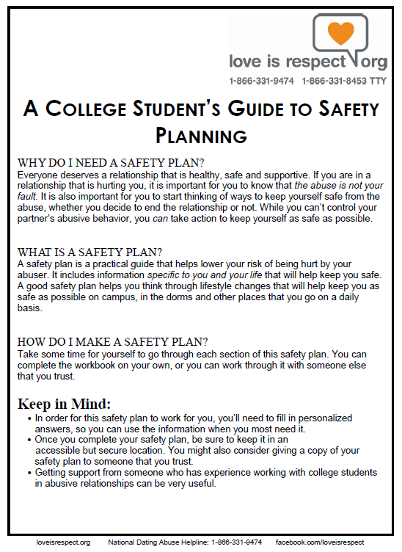
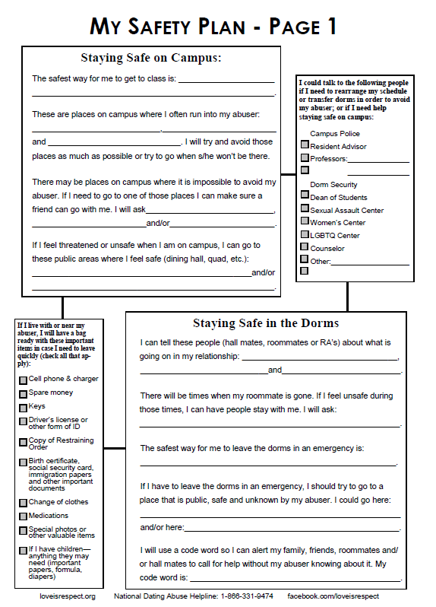
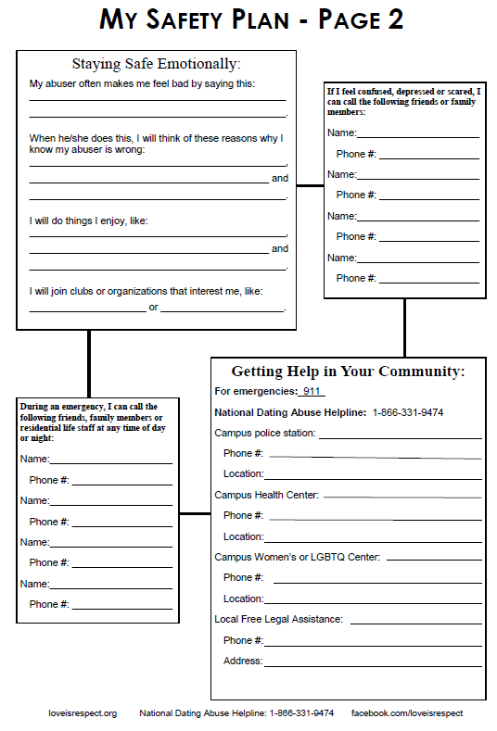
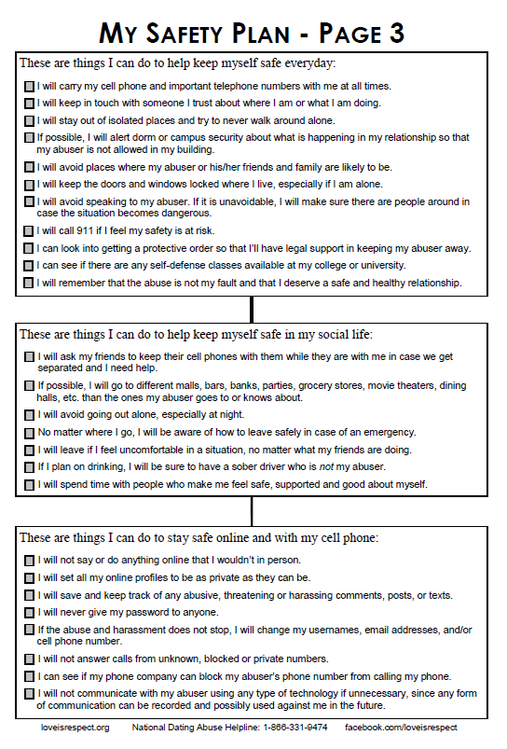

Sexual Assault Survivors Emergency Treatment Act (SASETA)

SASETA requires hospitals to provide the following minimum services to sexual assault survivors:
- Respond immediately to the survivor of sexual assault (Code R);
- Examine the victim in a private, closed room without presence of police;
- Provide appropriate tests, x-rays and treatment for injuries sustained;
- Provide survivor with a crisis intervention counselor, such as a Resilience advocate;
- Test the survivor for sexually transmitted infections (STIs) and for pregnancy;
- Provide survivor with necessary medications (antibiotics), not prescriptions;
- Directly bill the survivor’ public or private insurance carrier or the Illinois Department of Public Aid, if you have no insurance information. Under no circumstance should the survivor be billed for outpatient hospital charges, medication, or ambulance emergency care of transportations. A survivor has the right not to provide their private insurance information and the State of Illinois will be billed.

Crime Victim’s Compensation Information

You may be eligible for crime victim’s compensation through the Attorney General’s Office if:
- You experience a violent crime and sustain physical injuries;
- You are the survivor of a victim of a violent crime and were dependent upon the victim for support;
- You report the crime to the proper authorities within 72 hours and cooperate fully with law enforcement officials;
- Injury or death was not attributable to wrongful conduct or provocation;
- You are related to the victim/survivor and pay reasonable medical and/or funeral expenses.
Contact Resilience’s legal advocacy department for assistance in filing for compensation at 312/663-6303, or you can call the Attorney General’s Office at 1-800-228-3368.

Victims Economic Security and Safety Act (VESSA) of 2003
In accordance with the Illinois Victims Economic Security and Safety Act (VESSA) of 2003, leave shall be granted to an employee who is a victim of domestic or sexual violence or who has a family or household member who is a victim. Family or household member means a spouse, parent, son, daughter, and persons jointly residing in the same household. Parent means the biological parent of an employee or an individual who stood in loco parentis to an employee when the employee was a son or daughter. Son or daughter means a biological, adopted, or foster child, a stepchild, a legal ward, or a child of a person standing in loco parentis, who is under 18 years of age, or is 18 years of age or older and incapable of self-care because of a mental or physical disability.
All employees are eligible for 12 workweeks of leave during any 12-month period. The initial 12-month period is measured forward from the date the employee first takes VESSA leave. The next 12-month period begins the first time VESSA leave is taken after completion of any previous 12-month period. This Act does not create a right for the employee to take a leave that exceeds the leave time allowed under, or in addition to, the leave time permitted by the Family and Medical Leave Act. For employees on VESSA leave who are also eligible for FMLA leave, VESSA leave time is not in addition to the 12-week FMLA entitlement when the reason for VESSA leave also qualifies under FMLA, but depletes the 12-week FMLA entitlement when used. An employee who may have exhausted all available leave under FMLA, for a purpose other than that which is available under VESSA, remains eligible for leave under VESSA.
An employee shall be entitled, on return from leave, to be restored to the position held by the employee when the leave commenced, or to an equivalent position with equivalent benefits, pay, and other conditions of employment.
Domestic or sexual violence means domestic violence, sexual assault, or stalking. Domestic violence includes acts or threats of violence, not including acts of self defense, as defined in subdivision (3) of Section 103 of the Illinois Domestic Violence Act of 1986, sexual assault, or death to the person, or the person’s family or household member, if the conduct causes the specific person to have such distress or fear. Sexual assault means any conduct proscribed by the Criminal Code of 1961 in Sections 12-13, 12- 14, 12-14.1, 12-15, and 12-16. Stalking means any conduct proscribed by the Criminal Code of 1961 in Sections 12-7.3 and 12-7.4.
Rape Victim Advocates, JMP 8/05

Orders of Protection
How to Document Abuse
If you are in an abusive relationship and are in the process of taking (or deciding to take) legal action against your abusive partner, documentation of your partner’s abusive behaviors can be an important component of your case. It’s worth noting that each state has different laws about what evidence and documentation can be used in court. Speaking with a legal advocate in your state might better prepare you for your unique situation (advocates can help locate a legal advocate near you). Evidence can include:
- Verbal testimony from you or your witnesses
- Medical reports of injuries from the abuse
- Pictures (dated) of any injuries
- Police reports of when you or a witness called the police
- Household objects, clothing, or electronics broken or damaged by the abuser
- Pictures of your room/apartment in disarray or damaged property (holes punched in walls, thrown furniture, etc.) after a violent episode
- Pictures of weapons used by the abuser against you
- Screenshots of messages and online interactions
- A personal diary or notes on your phone in which you documented the abuse or interactions (with dates and details)
Creating Documentation
- Visit the doctor - More and more, doctors and gynecologists are trained to recognize signs of abuse. Your health care provider could also be a safe resource for disclosing the abuse. If you’re visiting a doctor for an injury, ask them about safe ways they can make notes about the abuse — ex. Some can write “cause of an injury” without it having to go to the police.
- Consider outside documentation - Do you have a trusted friend, coworker or family member who knows what’s going on and would be willing to help? There are many ways they can help document the abuse — whether that’s a coworker making note of times your partner calls you at the office, or a friend holding your journal at their house.
- Create a stalking log- If your partner is stalking you, creating a stalking log can be very helpful to your case. The National Stalking Prevention and Resource Center has examples of stalking logs as well as additional information on stalking.
- Take pictures - Your phone camera may not always be safe. Consider getting a disposable camera. Another option is for someone else to take the pictures and keep them for you.
- Screen Shots – Save messages or interactions on any social media platforms, send them to a trusted friend for safe keeping if needed. Especially on platforms like Instagram where messages can be unsent by the user. Also, be cautious of Snapchat where users are notified of screen shots, consider having a friend take a photo of your phone instead or using another device (like an iPad) to take the photo.
- Let a call go to voicemail - Is your partner calling over and over? Let it go to voicemail and save the voicemail
- Learn more about police reports – You can always ask questions. Call your local police department’s non-emergency number and find out about the protocols and procedures of filing a police report — ex. Like filing about a lost bike. Ask, “Hypothetically, if there was something that was happening that I would want to report…” This can help you prepare for filing a police report if you need to, which creates a paper trail of the abuse.

Steps for Getting an Order or Protection

- In Illinois, there are different types of Orders of Protection. Orders of Protection are civil court orders that ban the perpetrator from contacting you. If someone violates this order, it can become a criminal penalty.
- A description of the different types can be found at the Illinois Attorney General’s website. To file for an Order of Protection, you need a physical description of your abuser, their name and birthdate (or approximate age), and an address where they frequent. This address does not have to be their home, but the courts need an address to be able to serve the perpetrator the documents and notify them of the Order of Protection.
- If you have questions about what type of Order you may qualify for, the Illinois Domestic Violence hotline can provide information based on your specific situation.
- The paperwork can be downloaded and filled out on your own time or Illinois Legal Aid has an online help tool called “Easy Form” to make the paperwork easier to complete.
- You can choose to e-file for free or you can bring your completed paperwork to the local courthouse in the county you are filing. In Chicago, the Domestic Violence Court is located at 55 W. Harrison.
- Once you have filed, you should be given a court date. You can call the County Clerk to request a hearing date. The Cook County Clerk (the county serving Chicago) can be reached at 312-603-5030. You can request an Emergency Order of Protection date which will provide an initial hearing that the perpetrator (referred to as the respondent) is not required to attend. If the Emergency Order of Protection is granted, they last between 14-21 days until a full hearing can be scheduled. The hearing could be scheduled virtually or in person Both you and the respondent are expected to attend. If either party does not attend, the judge will likely make a decision without that person’s participation.
- For more information on what the court hearing looks like and what happens if the Order is granted, the Illinois Courts website has a step by step guide.

Wellness Center Services
The Wellness Center provides high quality interdisciplinary medical, mental health, and health promotion services that enable our diverse student.. At Loyola's Wellness Center, you will find medical, mental health, and health education professionals committed to your well-being. Together, we work to create a strong, safe campus community so that every Loyola experience is successful.
Survivors of Gender-Based Violence can access medical care, including Gynecological care, STI Testing, mental health services, and advocacy services through the Wellness Center. All services are free and confidential.
Students can call The Line at Loyola (773.494.3810) to speak directly to an advocate and find out how to be connected to services on and off campus, including medical and mental health care, reporting options, or other support.
Location
The Wellness Center has locations at all 3 Chicagoland campuses. The Lake Shore Campus Wellness Center is located at 6439 N. Sheridan Rd., Suite 310. The Water Tower Campus Wellness Center is located at 26 E. Pearson., Suite 250. The Health Science Campus Wellness Center is located in the Cuneo Center at 2160 S. 1st Ave, Maywood, IL 60153.
For more information about the Wellness Center including hours, services, and programs, a student self-care guide, events, and more, visit www.luc.edu/wellness.

Loyola’s Policies Regarding Sexual Misconduct
Domestic and Dating Violence is against Loyola’s policies. The specific policy can be found here.
For more information on Title IX, please visit www.luc.edu/titleix/.

To file an official report with the University about sexual misconduct, please visit www.luc.edu/cura.

Off-Campus Resources

If you want access to services outside of Loyola or more culturally-specific resources, below is a list of organizations that are available to help you.

Resilience (formerly Rape Victim Advocates)
312-443-9603 | www.ourresilience.org
Crisis intervention, medical and legal advocacy, and trauma therapy services are available to anyone in need of support in the Chicagoland area. As an independent rape crisis center and not-for-profit organization, they partner with local hospitals and organizations to deliver services 24 hours a day, seven days a week.

Center on Halsted Anti Violence Project
773-871-2273 | http://www.centeronhalsted.org/AVP.html
AVP at Center on Halsted provides comprehensive individual and community programs for survivor advocacy and support to LGBTQIA survivors of hate and bias violence, discrimination, intimate partner violence, stalking, and/or sexual assault. If you or someone you know has experienced violence, threats, or intimidation AVP can work with you to help ensure your safety and provide the support you need.

Between Friends (Chicago, IL – North Side)
1-800-603-4357 (24 hours) | https://www.betweenfriendschicago.org/
Between Friends is a nonprofit agency dedicated to breaking the cycle of domestic violence and building a community free of abuse. Between Friends’ programs and services include a toll-free Crisis Line (800-603-HELP), direct crisis intervention services for individuals and families, counseling for victims and their children, court advocacy, and prevention and education efforts, including healthcare education and teen dating violence prevention.

Legal Aid Chicago
312-341-1070 | https://www.legalaidchicago.org/
Provides free civil legal representation to residents of Chicago and Suburban Cook County who have limited income or special legal needs including Orders of Protection and No Contact Orders for victims of domestic or sexual violence.

Connections for Abused Women and their Children
773.278.4566 | https://www.cawc.org/
Connections for Abused Women and their Children (CAWC) is committed to ending domestic violence. Using a self-help, empowerment approach, we provide a shelter for adults and children, counseling, advocacy, and a 24-hour hotline for people affected by domestic violence. We work for social change through education, service collaboration, and institutional advocacy.

National Domestic Violence Hotline 1-800-799-7233 or chat with us online 24/7/365

Resilience Hospital Contact List

Advocate Illinois Masonic Medical Center
836 W Wellington Ave. Chicago, IL 60657
Emergency Department: 773-296-7078

AMITA Health Resurrection Center Chicago
7435 W Talcott Ave. Chicago, IL 60631
Emergency Department: 773-774-8000

Cermak Hospital located in the Cook County Jail
2800 S California Ave. Chicago, IL 60608
Emergency Department: 773-674-7488

Community First Medical Center
5645 W. Addison St. Chicago, IL 60634

John H. Stroger, Jr. Hospital of Cook County
1969 W Ogden Ave. Chicago, IL 60612
Emergency Department: 312-864-1300

Mount Sinai Hospital
1500 S Fairfield Ave. Chicago, IL 60608
Emergency Department: 773-257-6241

Northwestern Memorial Hospital
251 E Huron St. Chicago, IL 60611 (entrance is located on Erie St.)
Emergency Department: 312-926-5188

Provident Hospital of Cook County
500 E 51st St. Chicago, IL 60615
Emergency Department: 312-572-1700

Rush University Medical Center
1653 W Congress Parkway Chicago, IL 60612
Emergency Department: 312-942-4978

Saint Joseph’s Hospital
2900 N Lakeshore Dr. Chicago, IL 60657
Emergency Department: 773-665-3086

Saint Mary of Nazareth Medical Center
2233 W Division St. Chicago, IL 60622
Emergency Department: 312-770-2418

Swedish Covenant Hospital
5145 N California Ave. Chicago, IL 60625
Emergency Department: 773-989-3800

Thorek Hospital
850 W Irving Park Rd. Chicago, IL 60613
Emergency Department: 773-975-6770

University of Illinois Hospital (UIC)
1740 W Taylor St. Chicago, IL 60612
Emergency Department: 312-996-7279

Weiss Memorial Hospital
4646 N Marine Dr. Chicago, IL 60640
Emergency Department: 773-564-7500

West Suburban Medical Center
3 Erie Ct. Oak Park, IL 60302
Emergency Department: 708-763-6747

Resilience, 2023

